**Structural characterization of polysaccharides from*****Pachyrhizus erosus* and its protection against bile duct ligation-induced liver fibrosis**

Zijun Li a,b,c,1, Xiangwei Xu e,1, Lulu Yao b,1, Jujia Zheng a, Shuying Lou a, Jinguo Luo d, Kandasamy Saravanakumar b, Huafang Chen a, Fubo Hanf, Xudong Zhou d,*, Namki Cho b,*, Yiyuan Xi a,*

a Drug Clinical Trial Organization, The First Affiliated Hospital of Wenzhou Medical University, Wenzhou, 325000, Zhejiang, China

b Research Institute of Pharmaceutical Sciences, College of Pharmacy, Chonnam National University, Gwangju, 61186, Korea

c School of Pharmaceutical Sciences, Wenzhou Medical University, Wenzhou, 325000, Zhejiang, China

d TCM and Ethnomedicine Innovation and Development International Laboratory, School of Pharmacy, Hunan University of Chinese Medicine, Changsha, 410208, China.

e First People’s Hospital and School of Pharmaceutical Sciences, Hangzhou Medical College, Hangzhou, Zhejiang, People’s Republic of China

f State Key Laboratory of Macromolecular Drugs and Large-scale Preparation, School of Pharmaceutical Sciences and Food Engineering, Liaocheng University, Liaocheng 252000, China

Authors email ID

Zijun Li ([dalizijun1996@gmail.com](mailto:dalizijun1996@gmail.com))

Xiangwei Xu (xuxiangwei@hmc.edu.cn)

Lulu Yao ([YL261213@gmail.com](mailto:YL261213@gmail.com))

Jujia Zheng ([zhengjujia123@163.com](mailto:zhengjujia123@163.com))

Shuying Lou (lsy1230202@163.com)

Jinguo Luo (17378142275@163.com)

Kandasamy Saravanakumar ([saravana732@gmail.com](mailto:saravana732@gmail.com))

Huafang Chen ([chenhuafang@wmu.edu.cn](mailto:chenhuafang@wmu.edu.cn))

Fubo Han ([hanfubo@lcu.edu.cn](http://hanfubo@lcu.edu.cn))

Xudong Zhou (xudongzhou999@163.com)

Namki Cho ([cnamki@jnu.ac.kr](mailto:cnamki@jnu.ac.kr))

Yiyuan Xi (xiyiyuan1@wmu.edu.cn)

*Corresponding author:

Xudong Zhou (xudongzhou999@163.com)

Namki Cho ([cnamki@jnu.ac.kr](mailto:cnamki@jnu.ac.kr))

Yiyuan Xi (xiyiyuan1@wmu.edu.cn)

1These authors contributed equally to this work.

**Abstract**

Liver fibrosis is a reversible but clinically underserved stage of chronic liver disease, and safe microbiota-directed interventions are needed. Here, we isolated and structurally characterized a novel high-molecular-weight heteropolysaccharide, PEP-W-1, from *Pachyrhizus erosus*. GPC-MALS, GC–MS methylation analysis, and multidimensional NMR revealed a complex glucan–fructan backbone containing multiple α- and β-linked residues. In a bile duct ligation (BDL) mouse model, PEP-W-1 markedly reduced liver injury, improved serum liver enzymes, alleviated collagen and elastin deposition, and suppressed fibrotic markers including COL1A1, α-SMA, Fn1, and Acta2. These protective effects were largely abolished in antibiotic-treated mice, demonstrating a microbiota-dependent mechanism. 16S rRNA sequencing showed that PEP-W-1 restored microbial richness, normalized the Firmicutes/Bacteroidetes ratio, enriched beneficial SCFA-producing genera and reduced harmful taxa. Metagenomic profiling further revealed enhanced CAZyme families involved in glucan/fructan degradation and upregulation of KEGG orthologs mediating acetate, propionate, and butyrate biosynthesis, together with activation of tryptophan-derived IPA/IAA pathways and AhR-associated enzymes. Overall, PEP-W-1 attenuates liver fibrosis through coordinated modulation of gut microbial composition, carbohydrate-active enzyme capacity, and production of hepatoprotective metabolites, suggesting its potential as a microbiota-targeted therapeutic polysaccharide.

**Keyword**s: Polysaccharide, gut microbiota, liver fibrosis, gut-liver axis

1. **Introduction**

Liver fibrosis is a pathological condition caused by prolonged liver damage, which results from various factors, such as infections of hepatitis B virus (HBV) and hepatitis C virus (HCV), alcoholic fatty liver disease, non-alcoholic steatohepatitis, and cholestasis (Berumen, Baglieri, Kisseleva, & Mekeel, 2021; Kisseleva & Brenner, 2021). These disorders are characterized by common features, including chronic liver tissue damage, inflammatory responses, and progressive fibrosis (Hammerich & Tacke, 2023). This process disrupts the balance between the synthesis and degradation of the extracellular matrix (ECM), leading to abnormal collagen accumulation, and excessive fibrous tissue formation within the hepatic lobules and portal regions (Khurana, Sayed, Allawadhi, & Weiskirchen, 2021). Recent studies suggest that liver fibrosis represents an early and potentially reversible stage of chronic liver damage (Roehlen, Crouchet, & Baumert, 2020). However, without timely intervention and treatment, it can progress to irreversible cirrhosis or liver cancer, both of which are major contributors to liver disease-related mortality worldwide (Aslam & Kwo, 2023; Premkumar & Anand, 2022). Early and effective pharmacological treatments have the potential to prevent or reverse fibrosis, thereby reducing the risk of mortality from cirrhosis and liver cancer (Lambrecht, van Grunsven, & Tacke, 2020; C.-Y. Zhang, Liu, & Yang, 2023). Despite this, the precise mechanisms underlying liver fibrosis remain incompletely understood, and current clinical practice lacks reliable diagnostic and therapeutic approaches. Therefore, the development of effective strategies to prevent or reverse fibrosis is urgently needed.

The significant relationship between the gut-liver axis and liver diseases is receiving increasing attention (Han et al., 2023; X. Liu et al., 2021). Research indicates that the progression of conditions such as alcoholic liver disease, non-alcoholic liver disease, viral hepatitis, autoimmune hepatitis, and liver cancer is significantly influenced by gut microbiota (Arab, Arrese, & Shah, 2020; C. Liu et al., 2021). Impaired liver function increases the burden of the gut for uric acid excretion, leading to alterations to the composition of gut microbiota (Sheng et al., 2021; J. Wang et al., 2022). The imbalance of the gut microbiome triggers both local and systemic inflammation, which may further exacerbate liver dysfunction (Di Vincenzo, Del Gaudio, Petito, Lopetuso, & Scaldaferri, 2024; R. Wang, Tang, Li, Ma, Schnabl, & Tilg, 2021). Comparative studies of fecal microbiota from healthy individuals and patients with liver cirrhosis reveal a reduction in beneficial bacteria alongside an increase in harmful bacteria such as *Enterobacteriaceae* (Zeng et al., 2020). These harmful microbes disrupt the intestinal barrier, reduce short-chain fatty acid production, and interfere with amino acid metabolism, all of which can contribute to the progression of liver diseases (Ji et al., 2021; W. Liu et al., 2021). Therefore, maintaining gut microbial balance and restoring disrupted microbial metabolites may represent a promising strategy for the prevention of liver fibrosis.

The consumption of polysaccharide-rich foods plays a crucial role in shaping the composition of gut microbiota (Song et al., 2021; Xu, Xu, Ma, Tang, & Zhang, 2013). A diet rich in fruits, vegetables, fiber, and vitamins is typically associated with a more diverse gut microbial community (Beane et al., 2021; Sheflin, Melby, Carbonero, & Weir, 2017). *Pachyrhizus erosus* (PE), commonly known as jicama, is a plant native to tropical and subtropical regions (Ayeh, 2013). Its tuber, the main edible portion, is low in calories but rich in water, bioactive polysaccharides, and essential nutrients such as vitamin C, potassium, and antioxidants (Cuellar-Sánchez et al., 2024). Although PE has a sweet taste, it has a low glycemic index, making it an ideal option for individuals managing diabetes (Sarkar et al., 2024). Despite this, the effects of *Pachyrhizus erosus* polysaccharides (PEP) on gut microbiota (GM) regulation and their potential antifibrotic benefits remain largely unexplored. We hypothesize that PEP can ameliorate liver fibrosis by modulating GM composition, enhancing SCFAs production, and suppressing fibrogenic signaling pathways. This research aims to extract and isolate PEP, characterize its structure, and evaluate its protective effects in a bile duct ligation (BDL) induced liver fibrosis mouse model. Additionally, we will investigate the impact on GM to elucidate the underlying mechanisms by which they may exert antifibrotic activity.

1. **Material and methods**

2.1. Materials and chemicals

2.2. Preparation of PEP-W-1

Freshly harvested *Pachyrhizus erosus* tubers were sliced into 3 cm sections and extracted with boiling water at a 1:10 (w/v) ratio. The extraction was performed for 2 h and repeated three times. The combined extracts were concentrated and centrifuged to obtain the supernatant. The proteins were removed using the Sevag solution. The resulting supernatant was then concentrated and dialysised against distilled water using a dialysis membrane with a molecular weight cutoff (MWCO) of 14,000 Da for 3 days. Following dialysis, crude polysaccharides (PEP) were obtained by precipitating the solution with three volumes of 80% ethanol. Subsequently, 10 g of PEP was dissolved in 50 mL of distilled water and centrifuged at 10,000 ×g for 10 min. The supernatant was subjected to ion exchange chromatography using a DEAE Sepharose Fast Flow column with elution carried out sequentially using distilled water and NaCl solution at concentrations of 0.1, 0.2, and 0.3 mol/L. Each collected fraction was concentrated, dialyzed, and freeze-dried to yield distinct polysaccharide fractions: PEP-W, PEP-1, PEP-2, and PEP-3. Finally, 100 mg of PEP-W was dissolved in purified water and further purified using a Sephacryl S-300 column with distilled water as the eluent, resulting in the isolation of PEP-W-1.

2.3. Characterization of PEP-W-1

2.3.1. Molecular weight (Mw) analysis

The molecular weight (Mw) of PEP-W-1 was determined using gel permeation chromatography (GPC) equipped with a multi-angle laser light scattering detector (GPC-RI-MALS) (Wu et al., 2025). PEP-W-1 was dissolved in an aqueous solution of 0.1 M NaNO₃ containing 0.02% (w/w) NaN₃ at a final concentration of 1 mg/mL. The solution was filtered through a 0.45 μm membrane filter, and a 100 μL aliquot was injected for each run. The mobile phase consisted of 0.1 M NaNO₃ (phase A) and 0.02% (w/w) NaN₃ (phase B). Isocratic elution was carried out at a flow rate of 0.6 mL/min for 30 min.

2.3.2. Monosaccharide composition analysis

The monosaccharide composition of PEP-W-1 was analyzed using the method described earlier (J. Zhang et al., 2021). Briefly, 5 mg of PEP-W-1 was hydrolyzed with 1 mL of 2 M trifluoroacetic acid (TFA) by heating at 121°C for 4 h. After hydrolysis, the solution was evaporated to dryness under a stream of nitrogen gas. The residue was redissolved in methanol and dried again under nitrogen. This methanol dissolution and evaporation cycle was repeated three times to completely remove residual TFA. The final residue was dissolved in distilled water and subjected to ion chromatography using a Thermo ICS 5000+system (Thermo Fisher Scientific, USA) equipped with an electrochemical detector. Separations were performed using a Dionex™ CarboPac™ PA20 analytical column (150 × 3.0 mm, 10 μm) with a 5 μL injection volume. The mobile phases consisted of deionized water (phase A), 0.1 M NaOH (phase B), and a mixture of 0.1 M NaOH and 0.2 M sodium acetate (NaAc) (phase C). The column temperature was maintained at 30°C, and the flow rate was set at 0.5 mL/min.

2.3.3. Methylation analysis

Methylation of the polysaccharide samples was performed according to the procedure described in our previous study (Li et al., 2025). Briefly, 10 mg of PEP-W-1 was dissolved in 2 mL of dimethyl sulfoxide (DMSO), followed by the addition of 200 mg powdered NaOH. The mixture was stirred under a nitrogen atmosphere, and methylation was initiated by the dropwise addition of 1.5 mL of CH₃I. Upon completion, it was quenched with distilled water and then extracted with 3 mL of chloroform. The organic phase was washed three times with water. To ensure complete methylation, the procedure was repeated three times. The fully methylated polysaccharides were then hydrolyzed with 1 mL of 90% formic acid at 100 °C for 60 min. After evaporation of formic acid, further hydrolysis was carried out using 2 mL of 2 M trifluoroacetic acid (TFA) at 120 °C for 2 h. The resulting hydrolysates were subjected to reduction and acetylation to produce partially methylated alditol acetates (PMAAs). Finally, the PMAAs were analyzed using gas chromatography-mass spectrometry (GC-MS; 7890B-5977A, Agilent Technologies, USA) equipped with an HP-5MS capillary column (60 m × 0.25 mm × 0.25 μm, Agilent, USA).

2.3.4. Infrared spectrum and TGA analysis

The functional organic groups were identified by Fourier Transform Infrared Spectroscopy (IRTracer-100AH, Shimadzu Co., Japan).

2.3.5. Nuclear magnetic resonance (NMR)

The freeze-dried PEP-W-1 was dissolved in D2O to achieve a final concentration of 50 mg/mL. 1D and 2D NMR (including 1H NMR, 13C NMR, COSY, HMBC, and HSQC) were conducted at 25 °C using a Bruker AVANCE NEO 400 MHz spectrometer (Bruker, Rheinstetten, Germany).

2.4. Animals

Male C57BL/6J mice (4-6 weeks old, 20-25 g) were obtained from Vital River Laboratory Animal Technology Co., Ltd. The mice were housed under controlled conditions at 22 ± 2°C with a 12-hour light/dark cycle and had ad libitum access to food and water. All experimental procedures involving animals were approved by the Animal Ethics Committee of Wenzhou Medical University (approval protocol number: WYYY-IACUC-AEC-2025-092).

2.4.1. Experimental design

After a one-week acclimatization period, the mice were weighed and randomly assigned to four groups, ensuring an average body weight of 20–25 g. The groups were as follows: Group 1 (sham-operated control), Group 2 (BDL control), Group 3 (low-dose PEP-W-1, LPEP, 50 mg/kg), and Group 4 (high-dose PEP-W-1, HPEP, 200 mg/kg). In the sham group, a midline abdominal incision was made, and the wound was sutured without bile duct ligation; no additional treatment was administered. BDL was performed following the procedure. Specifically, mice were deeply anesthetized with intraperitoneal injections of ketamine (90 mg/kg body weight), xylazine (10 mg/kg), and ketoprofen (5 mg/kg). Under sterile conditions, a midline laparotomy was performed to expose the common bile duct, which was then ligated using 0-5 silk sutures. The bile duct was not ligated in the sham group, while the remaining protocol was identical to the BDL group. Following the surgery, the abdominal cavity was sutured, and the mice were placed on a warming pad for postoperative recovery. One day after surgery, the presence of dark-colored urine and yellowing of the ears was used to confirm the successful induction of cholestasis. The BDL group received no drug treatment. Mice in the LPEP and HPEP groups were treated with intraperitoneal injections of PEP-W-1 at doses of 50 mg/kg and 200 mg/kg, respectively, beginning on day 2 post-surgery and continuing daily until day 14. Body weights were recorded daily throughout the treatment period. On the 14th day, blood samples were collected via retro-orbital bleeding, and the mice were euthanized by cervical dislocation. The major organs were harvested and weighed to calculate the organ-to-body weight ratio (%). Liver tissues were snap frozen and stored at −80 °C for further biochemical and molecular analysis. The remaining liver tissues were used for Western blot analysis of protein expression, oxidative stress marker assays, and histopathological examination.

2.4.3. Assessment of plasma liver function enzymes

To evaluate the extent of liver damage induced by BDL, blood samples were collected and centrifuged to separate plasma. Levels of liver function biomarkers in plasma, including alanine aminotransferase (ALT), alkaline phosphatase (ALP), aspartate aminotransferase (AST), and total bilirubin, were enzymatically quantified using a commercial assay kit, following the manufacturer’s instructions (Sigma-Aldrich, St. Louis, MO, USA).

2.4.4. Histopathological and Immunohistochemical evaluation

For histopathological analysis, liver tissue from mice in each experimental group was fixed, embedded in paraffin, and sectioned into 5μm-thick slices. The sections were then deparaffinized, rehydrated, and stained with hematoxylin and eosin (H&E) for general histological evaluation. To assess fibrosis, the selected liver sections were stained with Masson's trichrome, and the number, length, and thickness of fibrous septa were measured in a blinded manner. For immunohistochemical detection of α-SMA, sections were blocked with 5% bovine serum albumin for 1 h at room temperature, followed by overnight incubation at 4°C with a mouse anti-human α-SMA primary antibody (1:200; Abcam). After washing, sections were incubated with an HRP-conjugated goat anti-rabbit IgG secondary antibody for 30 min. Detection was performed using a horseradish peroxidase (HRP)-labeled streptavidin-biotin system. The fibrotic area (%) in both CLILA1 and α-SMA-stained sections was quantified using ImageJ software (National Institutes of Health, Bethesda, MD, USA).

2.4.7. Immunoblotting for fibrotic markers

Liver tissue was homogenized, and total protein was extracted using RIPA buffer supplemented with protease inhibitors and phenylmethylsulfonyl fluoride (PMSF). Protein concentrations were determined, and equal amounts of protein were separated by electrophoresis on 10-15% SDS-polyacrylamide gels and transferred onto nitrocellulose membranes. Membranes were blocked with 5% bovine serum albumin (BSA) for 1 h at room temperature to prevent nonspecific binding, followed by overnight incubation at 4°C with specific primary antibodies (1:1000 dilution). After washing, membranes were incubated with HRP-conjugated secondary antibodies for 1 h at room temperature. Immunoreactive bands were visualized using an enhanced chemiluminescence detection system (ECL, Bio-Rad) and imaged using a ChemiDoc imaging system (Bio-Rad Laboratories, Hercules, CA, USA).

2.4.8. Real-time quantitative PCR (RT-qPCR) analysis

Total RNA was extracted from liver tissue using TRIzol reagent (Invitrogen, CA, USA) according to the manufacturer's instructions. Reverse transcription was performed using the RevertAid First Strand cDNA Synthesis Kit (ThermoFisher Scientific, Waltham, MA, USA). Quantitative PCR (qPCR) was conducted using HOT FIREPol EvaGreen qPCR Mix Plus (Solis Biodyne, Tartu, Estonia) on a PikoReal Real-Time PCR System (ThermoFisher Scientific). The amplification protocol included an initial activation step at 95°C for 15 min, followed by 40 cycles of denaturation at 95°C for 15 sec, annealing at 60°C for 20 sec, and extension at 72°C for 20 sec. Relative mRNA expression levels were calculated using the 2−∆∆Ct method, with actin serving as the reference gene. Primer sequences were designed using Primer3 (version 0.4.0) and validated using Netprimer software (Premier Biosoft, CA, USA).

2.5. Gut microbial analysis

On the eighth day, cecal contents from the mice were collected and stored at -80°C. Genomic DNA was extracted from the microbial communities using the EZNA® Soil DNA Kit (Omega Bio-Tek, Norcross, GA, USA), according to the manufacturer’s instructions. This extracted DNA was used as a template for PCR amplification of the V3-V4 variable regions of the 16S rRNA gene, employing the primers 338F (5′-ACTCCTACGGGAGGCAGCAG-3′) and 806R (5′-GGACTACHVGGGTWTCTAAT-3′) (Liu et al., 2016). PCR was performed using an ABI GeneAmp® 9700 thermal cycler (Applied Biosystems, USA). The PCR amplicons were then subsequently purified and used to construct sequencing libraries with the NEXTFLEX Rapid DNA-Seq Kit, followed by sequencing on the Illumina MiSeq PE300/NovaSeq PE250 platforms.

2.5. Statistical analysis

All data are presented as the mean ± standard deviation (SD), with all experiments performed in triplicate. Statistical analyses were conducted using GraphPad Prism 8 software. One-way analysis of variance (ANOVA) was used to assess statistical significance, and a p-value < 0.05 was considered statistically significant.

1. **Results**
   1. *Isolation, purification, and molecular weight analysis*

Crude PEP was obtained through hot water extraction, ethanol precipitation, and deproteinization. Further purification was performed using DEAE-52 cellulose and Sephacryl S-300 HR column chromatography, yielding PEP-W-1 with a recovery rate of 16.4% (Fig. 1A, S1). The molecular weight distribution of PEP-W-1 was analyzed by high-performance gel permeation chromatography (HPGPC), which revealed a single peak, suggesting a homogeneous molecular weight (Mw) distribution. Based on a dextran standard curve (log (Mw = −0.521*t + 10.132; R2 = 0.998), the Mw and polydispersity index (PDI) of PEP-W-1 were calculated to be 261.63 kDa and 1.33, respectively (Figure 1B).

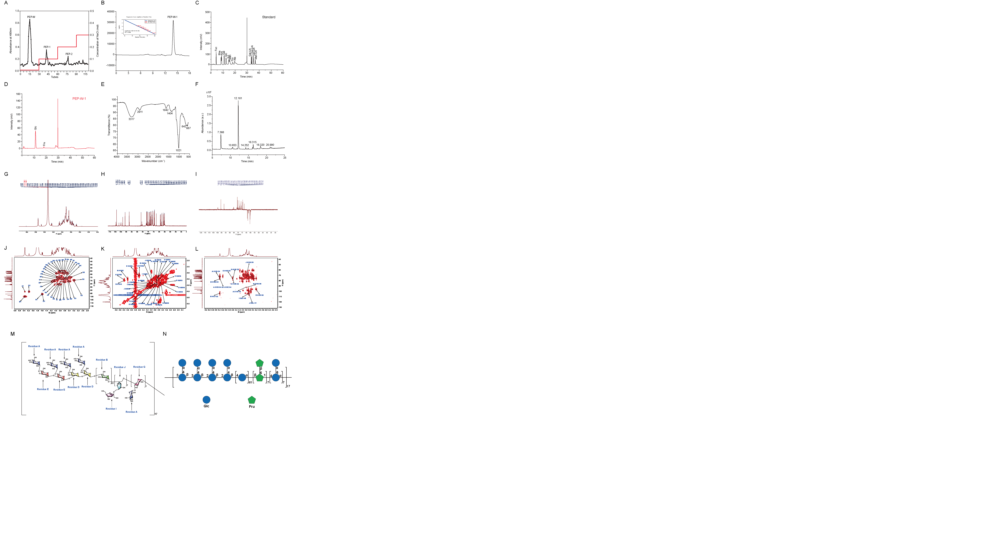

Fig. 1. Isolation and characterization of PEP-W-1. (A) Elution profiles of crude PEP on DEAE-Sepharose Fast Flow column. (B) The HPGPC chromatography of PEP-W-1. (C) HPAEC chromatogram analysis of standard monosaccharide. (D) HPAEC chromatogram analysis of monosaccharide composition in PEP-W-1. (E) FT-IR spectrum of PEP-W-1. (F) GC-MS total ion chromatogram of partially methylated alditol acetates (PMAAs) derived from PEP-W-1. (G) 1H NMR spectrum. (H) 13C NMR spectrum. (I) DEPT-135 spectrum. (J) HSQC spectrum. (K) 1H-1H COSY spectrum. (L) HMBC spectrum. (M) The structure of PEP-W-1 is represented using a structural formula. (N) The structure of PEP-W-1 is presented using symbols.

* 1. *Monosaccharide composition*

The monosaccharide composition analysis of PEP-W-1 was analyzed using an ion chromatography system equipped with UV-Vis detector. Compared with the standard monosaccharide spectrum, PEP-W-1 reveals two distinct characteristic peaks, indicating the presence of two monosaccharide components (Fig. 1C). As shown in Table S1, glucose and fructose were identified, with molar ratios of 95.16 and 2.68, respectively. Among them, glucose was the predominant component, suggesting that PEP-W-1 is primarily a neutral glucan.

* 1. *FT-IR analysis of PEP-W-1*

The types of glycosidic linkages and functional groups present in PEP-W-1 were inferred from its FT-IR spectrum. As shown in Figure 1E, PEP-W-1 exhibits characteristic polysaccharide absorption peaks at 3317 and 2911 cm⁻¹ which is associated with the stretching vibration of hydroxyl groups (-OH) and stretching vibration of carbon-hydrogen bonds (C-H). The 1404 cm⁻¹ peak results from the C-O stretching vibration, and the peak at 1021 cm⁻¹ related to the bound water. Moreover, the peak at 642 cm⁻¹ revealed the existence of *α*-configuration pyranose in PEP-W-1 (Yang & Zhang, 2009).

* 1. *Methylation analysis of PEP-W-1*

To investigate the glycosidic linkages, present in PEP-W-1, the sample underwent three rounds of methylation to ensure complete derivatization. The resulting partially methylated alditol acetates (PMAA) were analyzed using total ion chromatogram (TIC) (Fig. 1F). Gas chromatography-mass spectrometry (GC-MS) identified seven distinct glycosidic linkages in the PEP-W-1 derivatives, with their corresponding molar ratios summarized in Table S2.

*3.5 NMR analysis of PEP-W-1*

The 1H and 13C NMR spectra of PEP-W-1 exhibited characteristic chemical shifts indicative of a fructan-type polysaccharide (Fig. 1G and H). In the 13C NMR spectrum (Fig. 1H), two anomeric carbon signals in the range of δ104.01–103.23 ppm were assigned to the C-2 atoms of *β*-d-fructofuranose (Fruf) residues. Broad signals observed in the mid-to-low field region at 4.00–4.15 ppm and 4.15-4.25 ppm were attributed to the H-4 and H-3 protons of d-Fruf residues, respectively. In the 1H NMR spectrum, signals at δ5.17–5.35 ppm were assigned to the H-1 protons of α-D-glucopyranose (Glcp), while signals at δ4.57–4.59 ppm correspond to the H-1 of *β*-d-glucopyranose (Glcp).

The HSQC spectrum of PEP-W-1 revealed eight distinct cross-peaks at δH/C values of 5.34/92.1, 5.35/99.5, 4.57/95.8, 4.59/95.8, and 5.17/92.0, corresponding to residues A, B, D and E, respectively (Fig. 1J). Based on combined results of methylation analysis, monosaccharide composition, and NMR data, as well comparison with previously reported literature, the seven residues of PEP-W-1 were identified as α-d-Glcp-(1→, →4)-α-d-Glcp-(1→, →2,4)-*β*-d-Glcp-(1→, →3,4)-*β*-d-Glcp-(1→, →4,6)-*α*-d-Glcp-(1→, *β*-d-Fruf-(2→, and →1,6)-*β*-d-Fruf-(2→, corresponding to residues A, B, D, E, G, I, and J, respectively (Table S3). In the COSY spectrum (Fig. 1K), cross-peaks at 4.16/4.04 ppm, 4.04/3.76 ppm, and 3.76/3.65, 3.81 ppm were assigned to H3/H4, H4/H5, and H5/H6 correlation of residue I, respectively. Similar assignments were observed for residue J.

The linkage sites and sequences of the different sugar residues in PEP-W-1 were further elucidated by analyzing the correlation peaks in the HMBC spectrum (Fig. 1L). The correlation peak at 5.34/76.2 ppm (A H-1/G C-4) indicated that *O*-1 of residue A was linked to C-4 of residue G. Additional cross-peak at 4.57/76.5 ppm (D H-1/B C-4), 5.34/76.5 (A H-1/D C-4), 5.34/76.2 (A H-1/E C-4), 5.35/103.6 (B H-1/J C-2), 3.62/63.7 (J H-1/G C-6), 3.51/104.1 (J H-6/I C-2), 3.20/95.8 (D H-2/E C-1), revealed that that the *O*-1 of residue D was linked to C-4 of residue B, the *O*-1 of residue A was linked to C-4 of residue D, the *O*-1 of residue A was linked to C-4 of residue E, the *O*-1 of residue B was linked to C-2 of residue J, the *O*-1 of residue J was linked to C-6 of residue G, the *O*-6 of residue J was linked to C-2 of residue I, and *O*-2 of residue D was linked to C-1 of residue E, respectively. Additionally, the cross-peak at 5.35/76.5 (B H-1/B C-4) represented the *O*-1 of residue B, which was linked to residue B, indicating that residue B was a repeated unit in the structure of PEP-W-1. Similarly, the cross-peak at 4.57/75.6 (D H-1/D C-2), 4.59/75.8 (E H-1/E C-3), 3.63/92.0 (G H-6/G C-1), and 3.62/103.6 (J H-1/J C-2) revealed that residues D, E, G, and J were repeated in the structure of PEP-W-1. Further combining the results of Mw, monosaccharide composition analysis, GC-MS analysis, and NMR analysis of PEP-W-1, the primary structure of PEP-W-1 was inferred and is shown in Fig. 1M and N.

*3.5 PEP-W-1 ameliorates BDL-induced liver fibrosis in mice*

To evaluate the progression of hepatic fibrosis, both histopathological and biochemical changes in liver tissues were assessed in all experimental mice four weeks post-treatment. Compared with the control group, the BDL group exhibited characteristic signs of hepatic fibrosis, including yellowish peritoneal fluid, fibrotic nodules on the liver surface, irregular morphology, and disrupted hepatic lobe proportions (Fig. 2A). These pathological changes were markedly alleviated in the PEP-W-1-treated groups at doses of 50 mg/kg and 200 mg/kg, with the severity reduced in a dose-dependent manner. As liver fibrosis is commonly associated with increased liver weight and liver index, liver weight was measured after sacrifice to assess the degree of fibrosis and therapeutic efficacy. The liver weight index in the BDL group was approximately 1.4-fold higher than that of the sham-operated control group, confirming successful induction. Notably, PEP-W-1 treatment significantly reduced the liver index compared to the BDL model (Fig. 2B). No significant changes were observed in the weights of other major organs.

BDL leads to significant hepatocellular damage and fibrosis, resulting in elevated liver biomarker levels (Fig. 2C). Compared to sham-operated rats, BDL caused a notable increase in ALP and AST levels, indicating cholestasis and liver damage. Administration of both low and high doses of PEP partially lowered ALP levels, although the decrease was less pronounced than that observed in the control group. This suggests that PEP provides partial protection against BDL-induced liver damage, demonstrating hepatoprotective properties. Similarly, ALT levels were markedly elevated in BDL group. Both doses of PEP reduced ALT levels, with the higher dose showing a more substantial effect, suggesting that PEP mitigates liver injury and attenuates hepatocellular damage in a dose-dependent manner. Moreover, body weight was monitored daily throughout the experiment. No significant changes were observed in body weight in the control group, whereas BDL mice experienced substantial weight loss. In contrast, PEP-W-1-treated mice showed a gradual increase in body weight compared to the BDL group (Fig. 2D).

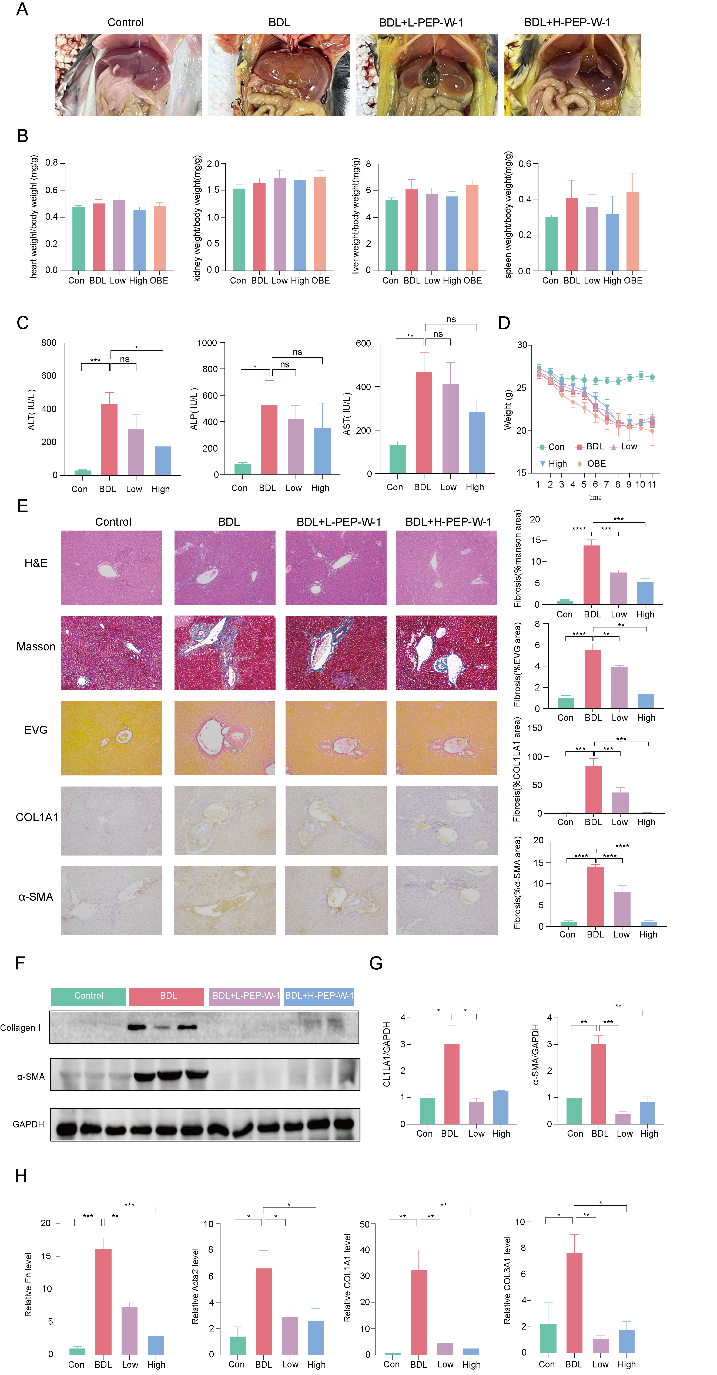

Fig. 2. Protective effects of PEP-W-1 on BDL-induced liver fibrosis in mice. (A) Representative morphology of livers from each group. (B) Ratio of major organ weight/ body weight. (C) Serum levels of ALT, ALP, AST. (D) Body weight changes during the treatment period. (E) Representative images of H&E staining, Masson staining, EVG staining, immunohistochemical staining of α-SMA and COL1A1 in liver tissues and corresponding fibrosis area quantification. (F) Western blot images showing protein expression of COL1A1 and α-SMA. (G) Quantification of COL1A1 and α-SMA. (H) Relative mRNA expression of Fn1, Acta 2, CL1LA1and COL3A1. Data are expressed as mean ± SD (n = 3). *p < 0.05, **p < 0.01, ***p < 0.001.

Histological examination using hematoxylin and eosin (HE) staining revealed a typical liver structure in control mice. In contrast, the BDL group exhibited severe tissue damage and fibrosis (Fig. 2E). In contrast, PEP-W-1 treatment improved liver structure in a dose-responsive manner, with the 200 mg/kg group showing the most significant reduction in fibrosis. This effect promoted tissue regeneration, protecting hepatocytes from necrosis, and aiding in the restoration of normal liver morphology. These results were corroborated by Masson’s trichrome staining, which showed minimal collagen deposition in the control group and extensive collagen accumulation, indicative of severe fibrosis, in the BDL group. PEP-W-1 treatment significantly reduced collagen deposition in a dose-dependent manner, with the 200 mg/kg dose producing the most substantial decrease in fibrotic tissue. Likewise, elastin Van Gieson (EVG) staining revealed a marked increase in elastin fibers in the BDL group, a sign of advanced fibrosis, which was progressively reduced as PEP-W-1 dosage increased, with the highest dose showing the most pronounced reduction in elastin content.

To further confirm the antifibrotic effect of PEP-W-1 *in vivo*, we examined the expression levels of key fibrotic markers at both protein and mRNA levels (Fig.2 E). COL1A1, a major extracellular matrix component, and α-SMA, a hallmark of activated hepatic stellate cells (HSCs), were evaluated by immunohistochemistry, western blot, and qPCR analysis. Immunohistochemical staining revealed markedly increased expression of COL1A1 and α-SMA in the BDL group, indicating active fibrosis and HSC activation (Fig. 2E). PEP-W-1 treatment significantly reduced the staining intensity of both markers in a dose-dependent manner, with the 200 mg/kg group showing the most pronounced reduction.

Consistent with these findings, western blot analysis showed elevated hepatic protein levels of COL1A1 and α-SMA in the BDL group compared to controls (Fig 2. F and G). Administration of PEP-W-1, especially at the high dose, led to a substantial suppression of both proteins, indicating its inhibitory effect on fibrogenic protein accumulation. To further validate these results, we assessed mRNA levels of fibrosis-related genes including Fn1, Acta2, COL1A1, and COL3A1 by quantitative PCR (Fig. 2H). The BDL group exhibited a significant upregulation of all four transcripts, reflecting enhanced fibrotic signaling. PEP-W-1 treatment significantly downregulated the expression of these genes in a dose-dependent fashion, supporting its anti-fibrotic potential at the transcriptional level. Taken together, these data strongly demonstrate that PEP-W-1 effectively attenuates liver fibrosis by suppressing both the transcription and translation of key fibrotic markers.

*3.6 PEP-W-1 improves BDL-induced liver fibrosis in a microbiota-dependent manner*

To determine whether the antifibrotic effects of PEP-W-1 depend on the gut microbiota, we evaluated its therapeutic efficacy in pseudo-germ-free (antibiotic-pretreated) mice subjected to BDL. Liver morphology revealed extensive swelling and biliary congestion in the BDL group. At the same time, PEP-W-1 treatment significantly alleviated these pathological changes in conventional mice (Fig. 3A). However, such protective effects were diminished mainly in antibiotic-treated (Abx) mice receiving PEP-W-1, suggesting the importance of microbiota. Serum biochemical analyses demonstrated that PEP-W-1 treatment significantly reduced the levels of ALT, AST, and TBIL in BDL mice. In contrast, this hepatoprotective effect was notably impaired in the Abx+PEP-W-1 group (Fig. 3B). These findings suggest that the presence of gut microbiota is essential for PEP-W-1 to restore liver function.

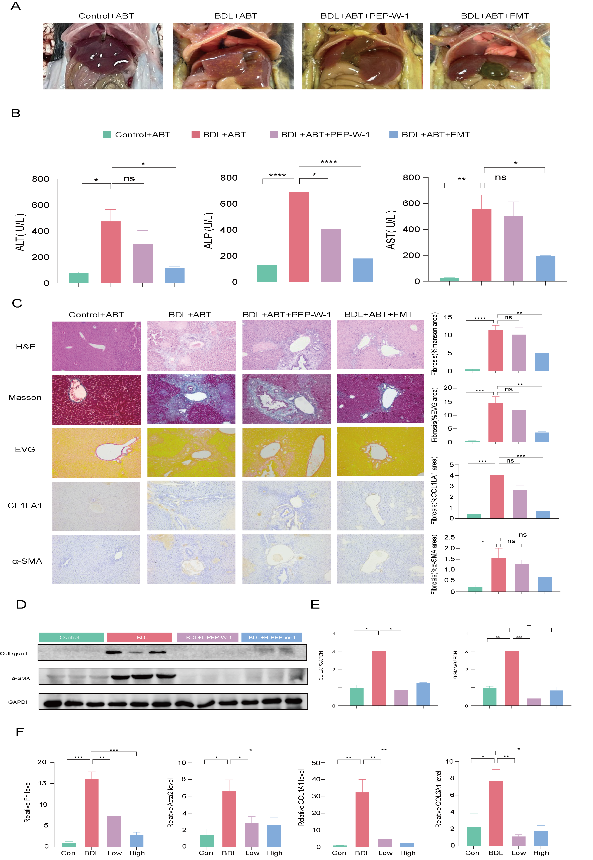

Fig 3. PEP-W-1 improves BDL-induced liver fibrosis in a microbiota-dependent manner. (A) Representative morphology of livers from each group. (B) Serum levels of ALT, ALP, AST. (C) Representative images of H&E staining, Masson staining, EVG staining, immunohistochemical staining of α-SMA and COL1A1 in liver tissues, and corresponding fibrosis area quantification. (D) Western blot images showing protein expression of COL1A1 and α-SMA. (E) Quantification of COL1A1 and α-SMA. (F) Relative mRNA expression of Fn1, Acta 2, CL1LA1and COL3A1.Data are expressed as mean ± SD (n = 6 mice each group). *p < 0.05, **p < 0.01, ***p < 0.001.

Histological examination further supported these observations (Fig. 3C). H&E staining revealed widespread hepatocyte necrosis and inflammatory infiltration in the BDL group, which PEP-W-1 markedly improved. Masson's trichrome and EVG staining indicated pronounced collagen and elastin deposition in BDL livers, while PEP-W-1 significantly reduced these fibrotic features in conventional but not Abx-treated mice. Immunohistochemical staining for α-SMA and COL1A1 showed similar trends: PEP-W-1 markedly suppressed myofibroblast activation and collagen accumulation in microbiota-intact mice, but this effect was significantly attenuated in Abx-treated animals. Western blot results showed that the expression of COL1A1 and α-SMA was markedly elevated in the BDL group compared to the Sham group (Fig. 3D and E). As expected, treatment with PEP-W-1 significantly reduced the protein levels of both markers in conventional mice. However, in antibiotic-pretreated mice, the suppressive effect of PEP-W-1 on COL1A1 and α-SMA expression was greatly diminished, suggesting a loss of efficacy in the absence of gut microbiota.

Consistent with protein-level changes, qPCR analysis revealed significant upregulation of fibrotic genes including Fn1, Acta2, Col1a1, and Col3a1 in the BDL group (Fig. 3F). PEP-W-1 significantly reversed these increases in microbiota-intact mice. In contrast, PEP-W-1 failed to downregulate these genes effectively in the Abx-treated group. These findings further support the notion that the antifibrotic effects of PEP-W-1 are mainly dependent on the presence of gut microbiota.

Collectively, these results demonstrate that the antifibrotic and hepatoprotective effects of PEP-W-1 are microbiota-dependent, highlighting a critical role for the gut-liver axis in mediating its therapeutic efficacy.

*3.7 PEP-W-1 regulated gut microbiota in BDL-induced liver fibrosis mice*

To investigate whether the therapeutic effects of PEP-W-1 on liver fibrosis are associated with gut microbiota modulation, we conducted 16S rRNA gene sequencing of fecal samples from control, BDL, and PEP-W-1-treated mice. As shown in Fig. 4A, alpha diversity analysis revealed that the BDL group exhibited significantly reduced microbial richness and diversity, as indicated by lower Chao1, ACE, Shannon, and Simpson indices compared to the control group. Treatment with PEP-W-1 markedly restored these diversity indices, suggesting that PEP-W-1 alleviates BDL-induced dysbiosis and enhances microbial community richness. Beta diversity analysis, using PCoA and NMDS plots based on Bray–Curtis distance (Fig. 4B), revealed a clear separation among the three groups. The microbial composition of the BDL group clustered distinctly away from the control and PEP-W-1 groups. Meanwhile, the PEP-W-1-treated mice showed a partial restoration toward the control group, suggesting that PEP-W-1 reshapes the overall gut microbial structure altered by cholestatic injury.

Taxonomic profiling at the phylum level revealed significant shifts in microbiota composition across groups (Fig. 4C). BDL-induced liver fibrosis led to an expansion of *Proteobacteria* and a reduction in *Bacteroidetes* and *Actinobacteria*; meanwhile, PEP-W-1 treatment significantly reversed these changes. In particular, the relative abundance of *Firmicutes* remained unchanged, but *Bacteroidetes* were enriched considerably, and *Proteobacteria*, a hallmark of microbial dysbiosis and inflammation, were dramatically reduced in the PEP-W-1 group (Fig. 4D). These findings suggest that PEP-W-1 restores microbial balance by suppressing harmful bacteria and promoting beneficial taxa. Moreover, the *Firmicutes/Bacteroidetes* (F/B) ratio—a commonly used indicator of gut microbial homeostasis—was significantly elevated in the BDL group and restored toward normal levels following PEP-W-1 treatment (Fig. 4E), further supporting the notion that PEP-W-1 re-establishes microbial equilibrium. Taken together, these results suggest that the antifibrotic effects of PEP-W-1 are associated with its ability to mitigate BDL-induced gut dysbiosis, particularly through suppression of *Proteobacteria* and normalization of the F/B ratio. This highlights the potential role of the gut–liver axis in mediating therapeutic effects of PEP-W-1 in models of liver fibrosis.

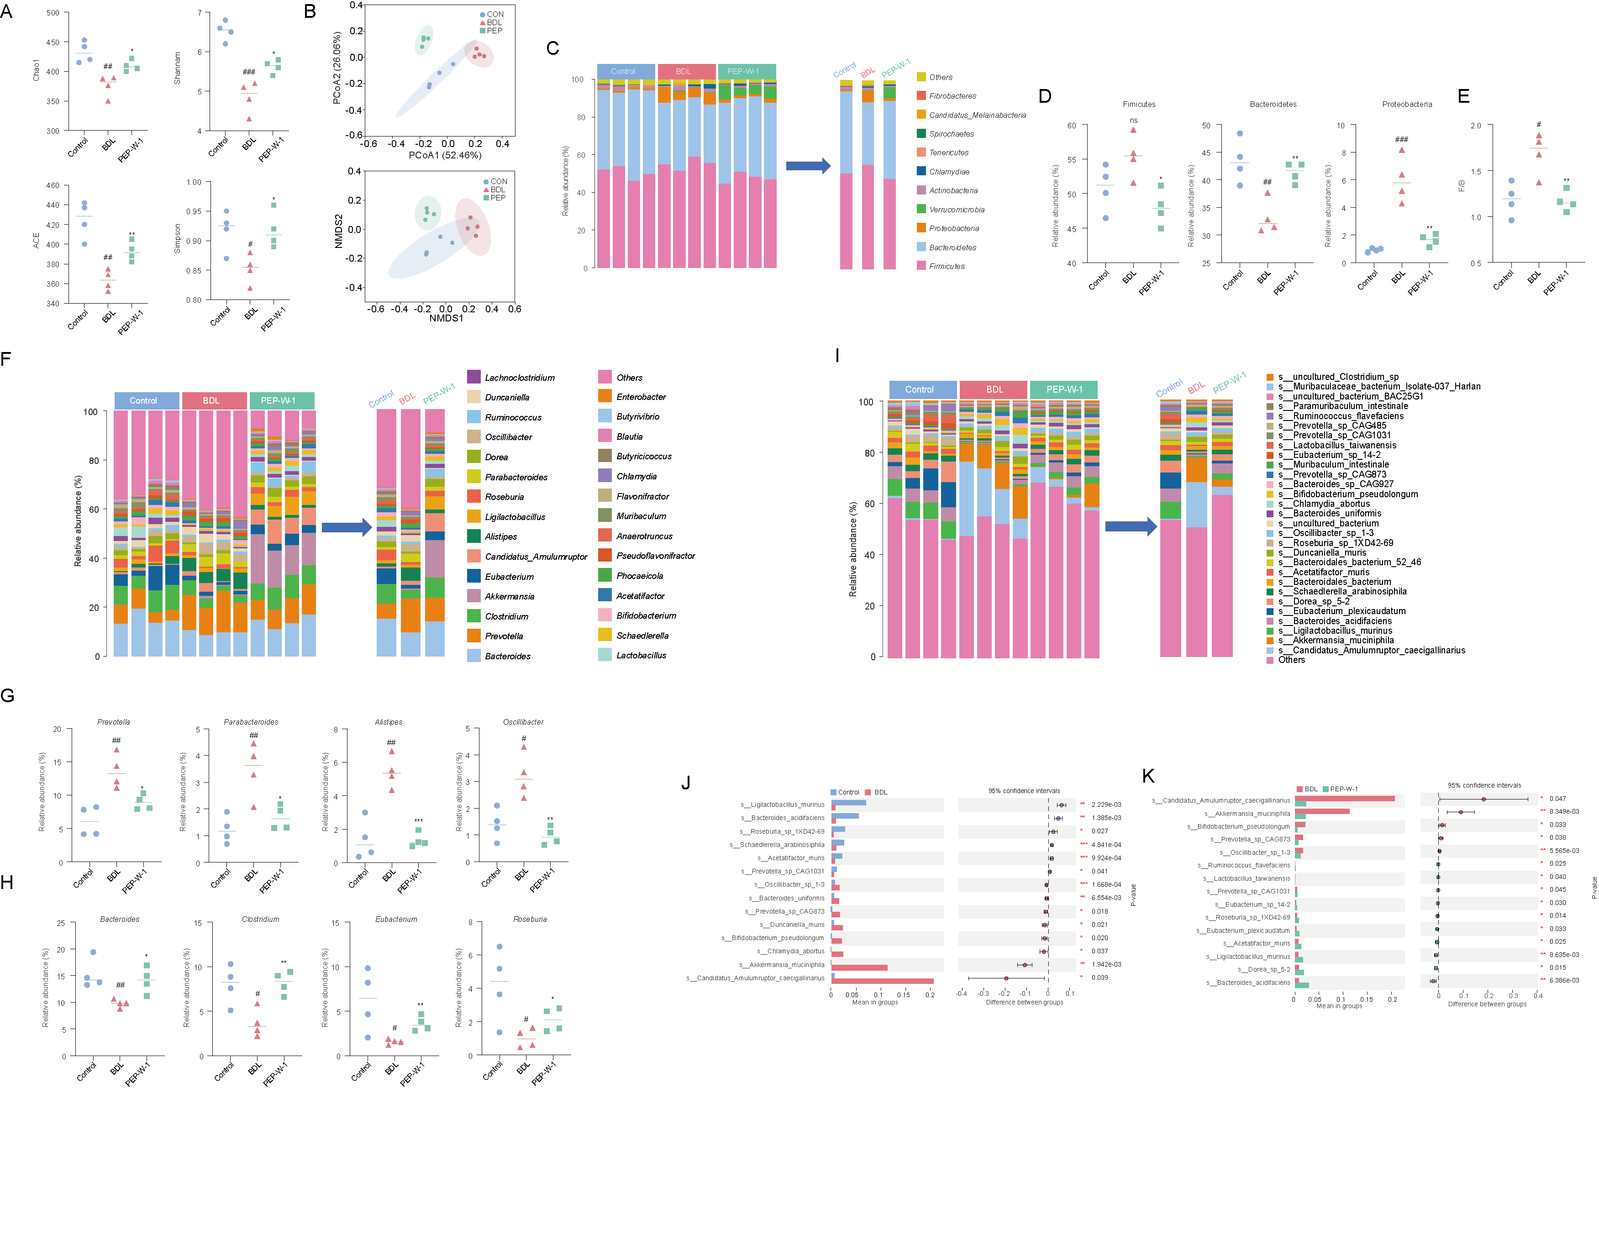

Fig 4. Effects of PEP-W-1 on GM composition in BDL-induced liver fibrosis mice. (A) Alpha diversity indices of microbial communities, including Shannon, Simpson, Chao1, and ACE indices. (B) Beta diversity analysis using PCA and NMDS plots. (C) Taxonomic composition of gut microbiota at the phylum level in different groups. (D) Relative abundance of *Firmicutes*, *Bacteroidetes* and *Proteobacteria*. (E) *Firmicutes/Bacteroidetes* (F/B) ratio. Modulation of GM by PEP-W-1 at genus level. (F) Relative abundance of bacterial genus. (G) Relative abundance of harmful bacterial genera. (H) Relative abundance of beneficial bacterial genera. (I) Relative abundance of bacterial genus. (J) Differentially abundant microbial species between the Control and BDL groups. (K) Differentially abundant microbial species between BDL and PEP-W-1 groups. Statistical differences were assessed using Welch’s t-test, followed by Benjamini–Hochberg false discovery rate (FDR) correction. *p < 0.05, **p < 0.01, ***p < 0.001. Statistically significant between BDL and control at ##*p* < 0.01, ####*p* < 0.0001; significance between BDL and treatments at \**p* < 0.05, \*\**p* < 0.01, \*\*\**p* < 0.001, \*\*\*\**p* < 0.0001 vs. BDL; ns=not significant.

To further elucidate the microbiota-level changes underlying the therapeutic effects of PEP-W-1, we profiled gut microbial composition at the genus level (Fig.4F). The BDL group displayed a marked expansion of potentially pathogenic genera (Fig. 4G) and a reduction of beneficial commensals compared to the control group (Fig. 4H). PEP-W-1 treatment restored the relative abundance of several key genera, suggesting a remodeling of the dysbiotic gut ecosystem. Specifically, the BDL group showed a decreased abundance of *Lactobacillus*, *Muribaculum*, and *Bacteroides*, which are commonly associated with anti-inflammatory and barrier-protective functions. PEP-W-1 administration significantly increased their levels, indicating enhanced microbial capacity for maintaining mucosal homeostasis. In contrast, the abundance of pro-inflammatory or opportunistic genera such as *Escherichia-Shigella*, *Desulfovibrio*, and *Enterococcus* was significantly elevated in the BDL group. PEP-W-1 effectively suppressed these genera, further supporting its microbiota-corrective action. Notably, *Escherichia-Shigella*, a hallmark of endotoxin-producing bacteria, was nearly abolished by PEP-W-1, suggesting reduced LPS load and downstream inflammatory burden. These findings highlight that PEP-W-1 not only restores overall microbial diversity but also selectively enriches beneficial genera while suppressing potentially pathogenic ones, reinforcing its role in microbiota-mediated protection against liver fibrosis. Such microbial shifts may contribute to improved barrier integrity, reduced endotoxemia, and attenuated hepatic stellate cell activation in BDL-challenged hosts.

To identify specific bacterial species involved in the microbiota-mediated effects of PEP-W-1, we performed species-level taxonomic profiling and differential abundance analysis. As shown in Fig.4I, BDL-induced liver fibrosis led to a profound shift in gut microbial composition, characterized by a marked reduction in beneficial commensals and a bloom of pro-inflammatory species. PEP-W-1 treatment partially restored the microbial landscape, as evidenced by increased diversity and rebalancing of several signature taxa. Further statistical comparisons (Fig.4J) between the Control and BDL groups revealed that fibrosis progression was associated with significant reductions in beneficial species such as *Ligilactobacillus murinus*, *Roseburia* sp*: 1XD42-69*, *Bacteroides acidifaciens*, and *Bifidobacterium pseudolongum*. In parallel, BDL promoted the overgrowth of pro-inflammatory or dysbiotic species, including *Candidatus Amulumruptor caecigallinarus* and *Akkermansia muciniphila*, which have been linked to mucus degradation and disruption of the barrier. Importantly, comparisons between BDL and PEP-W-1 groups (Fig. 4H) showed that PEP-W-1 significantly decreased the relative abundance of *Candidatus Amulumruptor caecigallinarus* and *Akkermansia muciniphila*, while simultaneously enriching beneficial species such as *Lactobacillus taiwanensis*, *Bifidobacterium pseudolongum*, and *Roseburia sp. 1XD42-69*. These microbial shifts suggest a reversal of fibrosis-associated dysbiosis by PEP-W-1. These findings highlight that PEP-W-1 exerts a selective remodeling effect at the species level, promoting the growth of short-chain fatty acid (SCFA)-producing and anti-inflammatory commensals, while suppressing the growth of mucin-degrading or endotoxin-associated taxa. This precise modulation of core microbial species may contribute to the restoration of intestinal barrier integrity and the mitigation of hepatic fibrogenesis.

*3.8. PEP-W-1 reshaped the gut microbial CAZyme profile in BDL-induced liver fibrosis mice*

As previously described, polysaccharides such as PEP-W-1 are primarily fermented by gut microbiota following oral administration. This microbial fermentation relies on carbohydrate-active enzymes (CAZymes), which break down complex glycosidic structures into fermentable monosaccharides and bioactive metabolites. To explore how PEP-W-1 modulates the functional capacity of gut microbiota in BDL-induced liver fibrosis, we annotated metagenomic datasets using the CAZy database (https://www.cazy.org/). We compared the abundance profiles of CAZyme families across groups.

PLS-DA analysis revealed distinct clustering of the Control, BDL, and PEP-W-1 groups based on their microbial CAZyme profiles (Fig. 5A), indicating that PEP-W-1 treatment reshaped the carbohydrate-degrading enzyme landscape disrupted by BDL. Notably, several CAZyme families were significantly enriched in the PEP-W-1 group, including glycoside hydrolases such as GH77, GH57, GH3, GH13, GH4, GH32, GH5, GH116 (Fig. 5B). According to CAZy and CAZypedia databases, these CAZymes participate in the breakdown of diverse plant-derived polysaccharide components (Fig. 5C). For instance, the GH13 and GH57 families encode a range of α-amylases, 4-α-glucanotransferases, and pullulanases, which hydrolyze α-1,4 and α-1,6-glucosidic bonds. Similarly, the GH3, GH4, and GH116 families comprise diverse β-glucosidases and MLG endo-*β*-1,3/1,4-glucanases, which target *β*-1,3, *β*-1,4, and mixed-linkage glucosidic bonds. Notably, GH31 contains α-glucosidases and dextranases that act on α-1,6 linkages in dextran-type side chains, while GH77 enzymes facilitate glucanotransferase activity, enabling rearrangement of α-glucan backbones. These activities suggest active remodeling of the polysaccharide structure, not just terminal cleavage. In addition, GH32 members, including inulinases and fructosidases, target *β*-2,1- and *β*-2,6-fructosidic bonds, which implies potential microbial utilization of fructan-like minor moieties or co-fermented dietary fibers. The possible modes of hydrolysis of PEP-W-1 by these major GHs are shown in Fig. 5D. To further explore the microbial origin of these enzymes, we examined the relationship between enriched CAZyme families and specific bacterial species. Gene-level predictions based on metagenomic annotation showed that CAZyme enrichment was tightly associated with the abundance of key microbial taxa (Fig. 5E). In the PEP-W-1 group, species such as *Akkermasia muciniphila*, *Roseburia so 1XD42-69*, *Bifidobacterium pseudolongum, and Ruminococcus flavefaciens* were enriched and predicted to encode GH116, GH13, GH3, GH31, GH3, and GT4 enzymes involved in glucan and fructan degradation, consistent with the structure of PEP-W-1. These results support the idea that PEP-W-1 promotes the selective expansion of microbial taxa capable of efficiently metabolizing its structural glycosyl motifs. The PEP-W-1-induced remodeling of the CAZyme landscape may thus contribute to its gut microbiota-mediated anti-fibrotic efficacy.

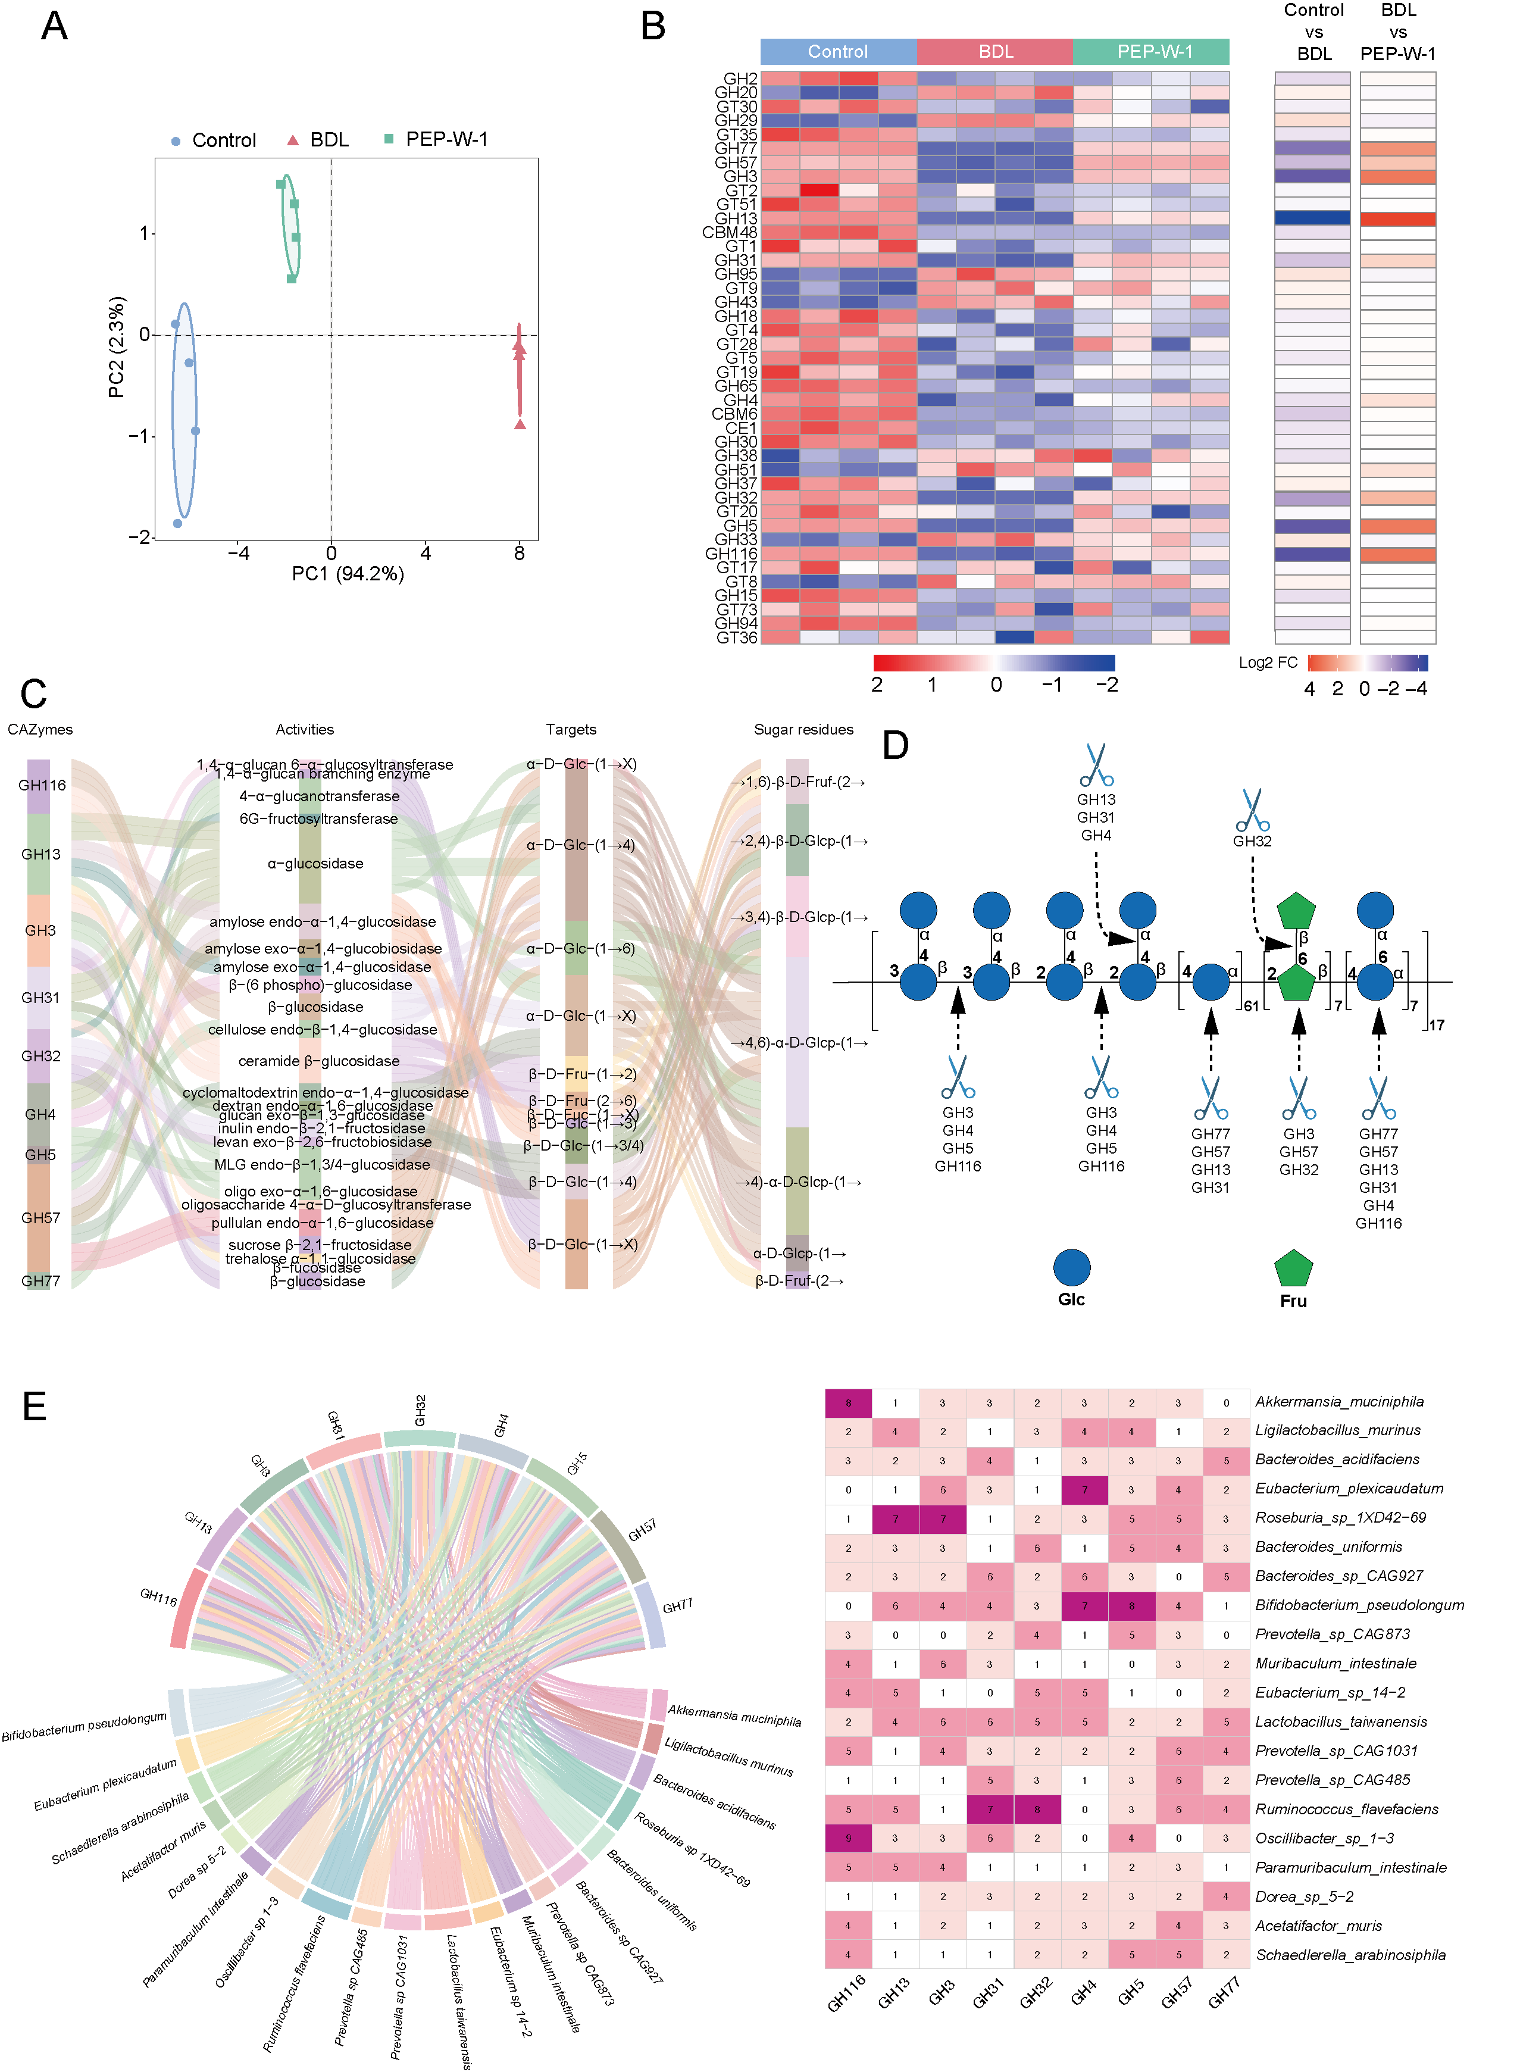

Fig 5. PEP-W-1 enriches the abundance of specific CAZymes encoded in the gut microbiota and reshapes functional pathways. (A) The intestinal microbial CAZymes profiles of the control group, BDL group, and PEP-W-1 treatment group in the PLS-DA score plot. (B) Heatmap of the abundance distribution of CAZymes in each group. (C) Specific CAZymes related to the glycosidic band showed significant differences among different groups. (D) Possible modes of hydrolysis of PEP-W-1 by different GHs. (E) Correlation analysis between enriched CAZymes and bacterial species.

*3.9. PEP-W-1 targets gut microbiota-encoded functional genes to enhance SCFA-associated metabolic pathways*

To explore how PEP-W-1 modulates microbiota-derived molecular pathways that may contribute to its anti-fibrotic effects, we annotated and analyzed microbial gene functions using the Kyoto Encyclopedia of Genes and Genomes (KEGG) database (https://www.genome.jp/kegg) based on shotgun metagenomic sequencing data. Functional annotation revealed that BDL induced significant changes in microbial functional genes, indicating targeted reprogramming of microbial functions. The altered KOs were primarily involved in carbohydrate metabolism, energy metabolism, and cofactor biosynthesis (Fig. S). Functional annotation of metagenomic data revealed that EPS-W-1 treatment significantly enriched multiple KEGG orthologs (KOs) associated with short-chain fatty acid (SCFA) biosynthesis, particularly within the glycolysis/gluconeogenesis, carbon metabolism, pyruvate metabolism, and butanoate metabolism pathways (Fig. 6A). Specifically, K00929 and K01034, both involved in butanoate metabolism, were upregulated in the EPS-W-1 group, suggesting enhanced microbial capacity for butyrate synthesis (Fig. 6B). In parallel, K01689, a multifunctional enzyme present in both glycolysis/gluconeogenesis and general carbon metabolism, was associated with increased formation of acetate, propionate, and butyrate, indicating broad activation of fermentative carbohydrate degradation routes. Notably, K00627—encoding pyruvate-flavodoxin oxidoreductase and other pyruvate-related enzymes—was enriched across multiple pathways, including glycolysis, pyruvate metabolism, and the TCA cycle, linking central carbon flux with downstream SCFA production. Similarly, K00134, a key glycolytic and carbon metabolism enzyme, was also associated with the formation of all three major SCFAs (acetate, propionate, and butyrate), supporting its central role in microbial energy metabolism. These data suggest that EPS-W-1 reshapes the microbial functional landscape to favor enhanced SCFA generation, with a notable emphasis on butyrate biosynthesis, likely contributing to its beneficial effects on host metabolism and intestinal health. We next examined which microbial species encoded these SCFA-related KOs using metagenomic annotation and the NCBI taxonomy database (https://www.genome.jp/kegg/genome/taxonomy.html). As shown in Fig. 6C, bacterial species enriched in the PEP-W-1 group—such as *Muribaculum intestinale*, *Acetatifactor muris*, and *Lactobacillus taiwanensis*—harbored more genes encoding K00627, K00929 and K01689. Correlation analysis (Fig. 6D) further revealed that *Ligilactobacillus murimus*, *Bacteroides acidifaciens*, and *Schaedlerella arabinosiphila* were positively associated with these KO. In contrast, fibrosis-related taxa such as *Escherichia-Shigella* and *Enterococcus faecalis* showed negative correlations. Taken together, these results indicate that PEP-W-1 promotes the enrichment of functional microbial genes responsible for SCFA biosynthesis, likely contributing to its antifibrotic effect through microbiota-derived metabolic modulation. The upregulation of key KOs involved in acetate and propionate pathways suggests that PEP-W-1 may rewire the metabolic potential of the gut microbiome to favor anti-inflammatory and hepatoprotective outputs.

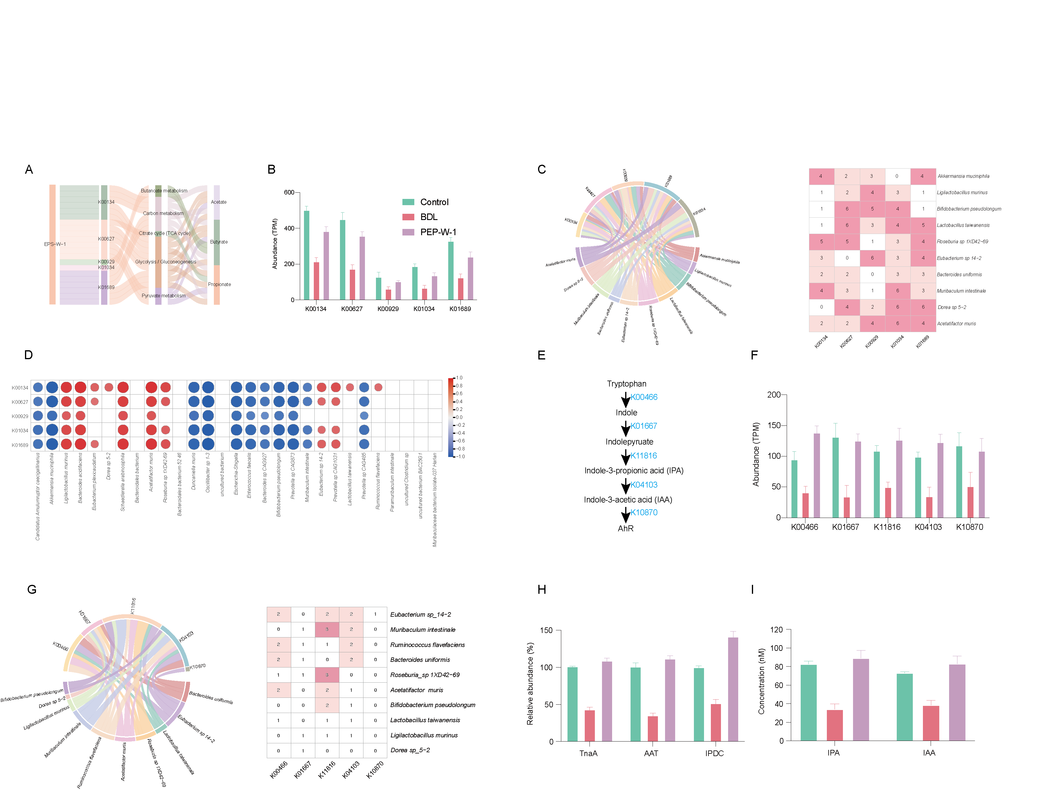

Fig 6. PEP-W-1 regulates microbial genes related to SCFA metabolism. (A) PEP-W-1 altered KO (compared to the BDL group) was involved in SCFA metabolism. (B) PEP-W-1 upregulated KOs related to acetate, propionate, and butyrate production, with abundance expressed as cumulative TPM (transcripts per million). (C) Correlation analysis between SCFA-related KOs and enriched bacterial species in the same group. (D) Spearman analysis of enriched KO and gut microbiota. (E) PEP-W-1 treatment altered KOs mediating responses associated with the AhR pathway. (F) PEP-W-1 upregulated KOs in the AhR pathway, and the abundance was expressed as cumulative TPM (transcripts per million). (G) Correlation analysis of AhR-associated KOs with bacterial species enriched in the same group. (H) PEP-W-1 treatment increased the activities of TnaA, AAT, and IPDC in the intestine. (I) PEP-W-1 treatment increased the concentrations of IPA and IAA.

*3.10 PEP-W-1 enhances tryptophan metabolism and promotes IPA/IAA biosynthesis via gut microbiota-derived pathways*

To explore the functional interaction between PEP-W-1 and gut microbiota-derived tryptophan metabolism, we reconstructed microbial metabolic pathways based on metagenomic KO annotation using the KEGG database. As illustrated in Fig. 6E, the biosynthetic conversion of tryptophan into indole-3-propionic acid (IPA) and indole-3-acetic acid (IAA) involves a sequence of key enzymes encoded by K00466, K01667, K18116, K04103, and K10870, eventually activating the aryl hydrocarbon receptor (AhR) signaling pathway. PEP-W-1 treatment significantly upregulated the abundance of these KOs compared to the BDL group (Fig. 6F), suggesting enhanced microbial potential for IPA/IAA production. Among them, K01667 (aromatic amino acid transaminase) and K18116 (indolepyruvate decarboxylase) were particularly elevated in the PEP-W-1 group, which are directly involved in the conversion of tryptophan to indolepyruvate and subsequently to IPA.

To identify microbial contributors to these KO pathways, we performed taxonomic tracing of gene carriers using KEGG taxonomy mapping. As shown in the chord diagram and abundance heatmap (Fig. 6G), species including *Eubacterium sp. 14-2*, *Muribaculum intestinale*, *Bacteroides uniformis*, and *Roseburia sp. 1XD42-69* were enriched in the PEP-W-1 group and predicted to encode multiple IPA/IAA-related KOs. Consistent with these findings, the abundance of microbial enzymes TnaA (tryptophanase), AAT (aromatic amino acid transaminase), and IPDC (indolepyruvate decarboxylase)—key enzymes involved in tryptophan-to-indole metabolite conversion—were significantly increased in the PEP-W-1 group relative to BDL (Fig. 6H).

Furthermore, direct quantification of microbial tryptophan metabolites demonstrated that the concentrations of IPA and IAA were markedly elevated in PEP-W-1-treated mice compared to the BDL group (Fig. 6I), confirming that PEP-W-1 enhances microbial metabolism of tryptophan along the IPA/IAA axis. Collectively, these results indicate that PEP-W-1 selectively promotes microbial taxa and functional genes responsible for IPA/IAA biosynthesis, which may further activate AhR signaling and contribute to the compound’s immunoregulatory and antifibrotic effects.

1. **Conclusion**

In this study, we successfully isolated and characterized a novel polysaccharide fraction, PEP-W-1, from *Pachyrhizus erosus* tubers. Structural elucidation revealed that PEP-W-1 is a glucose- and fructose-based heteropolysaccharide with a high molecular weight and a complex backbone consisting of multiple glycosidic linkages. Functionally, PEP-W-1 exhibited significant protective effects against bile duct ligation (BDL)-induced liver fibrosis in mice. It alleviated hepatic injury, suppressed the expression of fibrotic markers, and improved histopathological features in a dose-dependent manner. Mechanistic investigations demonstrated that the antifibrotic efficacy of PEP-W-1 is largely microbiota-dependent. PEP-W-1 restored gut microbial diversity, reversed fibrosis-associated dysbiosis, and enriched beneficial taxa such as Bifidobacterium, Lactobacillus, and Roseburia, while suppressing pro-inflammatory genera including Escherichia-Shigella and Akkermansia. Metagenomic analysis revealed that PEP-W-1 modulated microbial carbohydrate-active enzyme (CAZyme) profiles, enhancing the degradation of complex glycosidic structures and promoting SCFA production. Additionally, PEP-W-1 activated gut microbiota–derived tryptophan metabolic pathways leading to increased levels of immunomodulatory metabolites, indole-3-propionic acid (IPA) and indole-3-acetic acid (IAA), suggesting a possible involvement of the AhR signaling axis. Collectively, these findings highlight that PEP-W-1 ameliorates liver fibrosis through coordinated modulation of gut microbiota composition, enzymatic functionality, and microbial metabolite production. This work provides new insights into the structure-function relationship of dietary polysaccharides and their therapeutic potential for microbiota-targeted interventions in chronic liver diseases.

**CRediT authorship contribution statement**

Zijun Li contributed to Writing – original draft, Writing – review & editing, Methodology, Investigation, Data curation, Formal analysis, and Conceptualization. Xiangwei Xu contributed to Investigation, Methodology, Formal analysis, and Data curation. Lulu Yao contributed to Investigation, Formal analysis, and Validation. Jujia Zheng contributed to Investigation and Resources. Shuying Lou contributed to Investigation and Data curation. Jinguo Luo contributed to Resources and Validation. Kandasamy Saravanakumar contributed to Writing – review & editing, Methodology, Investigation, and Formal analysis. Huafang Chen contributed to Investigation and Visualization. Xudong Zhou contributed to Supervision, Resources, Project administration, and Writing – review & editing. Namki Cho contributed to Writing – review & editing, Supervision, Visualization, Project administration, Resources, and Conceptualization. Yiyuan Xi contributed to Conceptualization, Supervision, Funding acquisition, Project administration, and Writing – review & editing.

**Declaration of interests**

The authors declare that they have no known competing financial interests or personal relationships that could have influenced the work reported in this paper.

**Acknowledgments**

This work was supported by the Natural Science Foundation of Hunan Province (grant number: 2024JJ8194); the Jinhua City Science and Technology Project (grant number: 2024-3-144); and the Zhejiang Traditional Chinese Medicine Project (grant number: 2026ZL0488).

**Data availability statement**

The data that support the findings of this study are available from the corresponding author, Yiyuan Xi, upon reasonable request.

**Reference**

Arab, J. P., Arrese, M., & Shah, V. H. (2020). Gut microbiota in non‐alcoholic fatty liver disease and alcohol‐related liver disease: Current concepts and perspectives. *Hepatology Research,* 50(4), 407-418.

Aslam, A., & Kwo, P. Y. (2023). Epidemiology and disease burden of alcohol associated liver disease. *Journal of Clinical and Experimental Hepatology,* 13(1), 88-102.

Ayeh, E. S. (2013). Development and quality characteristics of yam bean (Pachyrhizus erosus) flour and its performance in bread. Citeseer.

Beane, K. E., Redding, M. C., Wang, X., Pan, J. H., Le, B., Cicalo, C., . . . Shin, E.-C. (2021). Effects of dietary fibers, micronutrients, and phytonutrients on gut microbiome: a review. *Applied Biological Chemistry,* 64, 1-18.

Berumen, J., Baglieri, J., Kisseleva, T., & Mekeel, K. (2021). Liver fibrosis: Pathophysiology and clinical implications. *WIREs mechanisms of disease,* 13(1), e1499.

Cuellar-Sánchez, V., Arreguín-Centeno, J. H., González-Vázquez, M., Salgado-Cruz, M. d. l. P., Farrera-Rebollo, R. R., Gutiérrez-López, G. F., & Calderón-Domínguez, G. (2024). Effect of Biotic Stress Due to Phyllophaga spp. on Antioxidant Compounds during Jicama Root (Pachyrhizus erosus) Development. *Horticulturae,* 10(5), 485.

Di Vincenzo, F., Del Gaudio, A., Petito, V., Lopetuso, L. R., & Scaldaferri, F. (2024). Gut microbiota, intestinal permeability, and systemic inflammation: a narrative review. *Internal and emergency medicine,* 19(2), 275-293.

Hammerich, L., & Tacke, F. (2023). Hepatic inflammatory responses in liver fibrosis. *Nature reviews Gastroenterology & hepatology,* 20(10), 633-646.

Han, H., Jiang, Y., Wang, M., Melaku, M., Liu, L., Zhao, Y., . . . Zhang, H. (2023). Intestinal dysbiosis in nonalcoholic fatty liver disease (NAFLD): focusing on the gut–liver axis. *Critical reviews in food science and nutrition,* 63(12), 1689-1706.

Ji, X., Chen, M., Zhao, M., Song, Y., Lin, Y., Yin, H., & Zhao, L. (2021). Effects of chitooligosaccharides on the rebalance of gut microorganisms and their metabolites in patients with nonalcoholic fatty liver disease. *Journal of Functional Foods,* 77, 104333.

Khurana, A., Sayed, N., Allawadhi, P., & Weiskirchen, R. (2021). It’s all about the spaces between cells: Role of extracellular matrix in liver fibrosis. *Annals of translational medicine,* 9(8).

Kisseleva, T., & Brenner, D. (2021). Molecular and cellular mechanisms of liver fibrosis and its regression. *Nature reviews Gastroenterology & hepatology,* 18(3), 151-166.

Lambrecht, J., van Grunsven, L. A., & Tacke, F. (2020). Current and emerging pharmacotherapeutic interventions for the treatment of liver fibrosis. *Expert opinion on pharmacotherapy,* 21(13), 1637-1649.

Li, Z., Saravanakumar, K., Park, S., Yao, L., Kim, Y., Jo, J., . . . Cho, N. (2025). Structural characterization and therapeutic potential of exopolysaccharide EPS-W-1 from Lactiplantibacillus plantarum strain ZL1 isolated from kimchi against DSS-induced colitis. *Carbohydrate Polymers*, 123997.

Liu, C., Wang, Y. L., Yang, Y. Y., Zhang, N. P., Niu, C., Shen, X. Z., & Wu, J. (2021). Novel approaches to intervene gut microbiota in the treatment of chronic liver diseases. *The FASEB Journal,* 35(10), e21871.

Liu, W., Luo, X., Tang, J., Mo, Q., Zhong, H., Zhang, H., & Feng, F. (2021). A bridge for short-chain fatty acids to affect inflammatory bowel disease, type 1 diabetes, and non-alcoholic fatty liver disease positively: By changing gut barrier. *European journal of nutrition,* 60, 2317-2330.

Liu, X., Sun, R., Li, Z., Xiao, R., Lv, P., Sun, X., . . . Gong, Y. (2021). Luteolin alleviates non-alcoholic fatty liver disease in rats via restoration of intestinal mucosal barrier damage and microbiota imbalance involving in gut-liver axis. *Archives of biochemistry and biophysics,* 711, 109019.

Premkumar, M., & Anand, A. C. (2022). Overview of complications in cirrhosis. *Journal of Clinical and Experimental Hepatology,* 12(4), 1150-1174.

Roehlen, N., Crouchet, E., & Baumert, T. F. (2020). Liver fibrosis: mechanistic concepts and therapeutic perspectives. *Cells,* 9(4), 875.

Sarkar, A., Khan, A. S., Kaul, R., Lee, S., Kamal, I., Paul, P., . . . Chaari, A. (2024). The Link between Gut Microbiome, Nutraceuticals, Diet, and Diabetes Mellitus: A Bibliometric and Visual Analysis of Research and Emerging Trends from 2012 to 2022.

Sheflin, A. M., Melby, C. L., Carbonero, F., & Weir, T. L. (2017). Linking dietary patterns with gut microbial composition and function. *Gut microbes,* 8(2), 113-129.

Sheng, S., Chen, J., Zhang, Y., Qin, Q., Li, W., Yan, S., . . . Tang, L. (2021). Structural and functional alterations of gut microbiota in males with hyperuricemia and high levels of liver enzymes. *Frontiers in Medicine,* 8, 779994.

Song, Q., Wang, Y., Huang, L., Shen, M., Yu, Y., Yu, Q., . . . Xie, J. (2021). Review of the relationships among polysaccharides, gut microbiota, and human health. *Food Research International,* 140, 109858.

Wang, J., Chen, Y., Zhong, H., Chen, F., Regenstein, J., Hu, X., . . . Feng, F. (2022). The gut microbiota as a target to control hyperuricemia pathogenesis: Potential mechanisms and therapeutic strategies. *Critical reviews in food science and nutrition,* 62(14), 3979-3989.

Wang, R., Tang, R., Li, B., Ma, X., Schnabl, B., & Tilg, H. (2021). Gut microbiome, liver immunology, and liver diseases. *Cellular & molecular immunology,* 18(1), 4-17.

Wu, Z.-W., Liu, X.-C., Quan, C.-X., Tao, X.-Y., Yi, L., Zhao, X.-F., . . . Qiu, M.-H. (2025). Novel galactose-rich polysaccharide from Ganoderma lucidum: structural characterization and immunomodulatory activities. *Carbohydrate Polymers,* 362, 123695.

Xu, X., Xu, P., Ma, C., Tang, J., & Zhang, X. (2013). Gut microbiota, host health, and polysaccharides. *Biotechnology Advances,* 31(2), 318-337.

Yang, L., & Zhang, L.-M. (2009). Chemical structural and chain conformational characterization of some bioactive polysaccharides isolated from natural sources. *Carbohydrate Polymers,* 76(3), 349-361.

Zeng, Y., Chen, S., Fu, Y., Wu, W., Chen, T., Chen, J., . . . Ou, Q. (2020). Gut microbiota dysbiosis in patients with hepatitis B virus–induced chronic liver disease covering chronic hepatitis, liver cirrhosis and hepatocellular carcinoma. *Journal of viral hepatitis,* 27(2), 143-155.

Zhang, C.-Y., Liu, S., & Yang, M. (2023). Treatment of liver fibrosis: Past, current, and future. *World Journal of Hepatology,* 15(6), 755.

Zhang, J., Song, Z., Li, Y., Zhang, S., Bao, J., Wang, H., . . . Guo, Y. (2021). Structural analysis and biological effects of a neutral polysaccharide from the fruits of Rosa laevigata. *Carbohydrate Polymers,* 265, 118080.